COMMENTS and COMPLAINTS PROCEDURES

FURZEDOWN YOUTH CENTRE
WELHAM ROAD
LONDON
SW16 6NT

June 2019
Comments

Introduction

Furzedown Youth Centre (FYC) has grown and gained an excellent reputation partially due to our commitment to listening to users, their parents, our volunteers and the community FYC serves. Therefore we welcome all comments that help us shape our service to meet the needs of those we seek to serve. Comments may be written or verbal and will be considered at senior staff and board level when appropriate.

Complaints

Introduction

The purpose of the Complaints Procedure is to ensure a high level of service to our staff, volunteers and users, and to help you to tell us when things go wrong. The primary aim is to encourage improvement in our services and to ensure that everything we do is in line with our aims and policies.
Usually, when a problem arises with the delivery of our services, we can correct this simply and easily without additional formality. However, we recognise that there may be occasions when users and volunteers feel that the quality or level of service provision falls short of what they could reasonably expect and that it is necessary to raise a formal complaint.

If you have a complaint, please discuss the issue with a member of staff if you are a user or parent, or your named supervisor if you are a volunteer. However, if the complaint is against the person mentioned above, or if the complaint is not dealt with to your satisfaction in a reasonable amount of time, then follows the procedure below.

FYC is committed to ensuring that your complaint is dealt with fairly and equally, regardless of
- race, ethnic or national origin;
- sex;
- HIV status;
- actual or perceived sexual orientation;
- age;
- religion or belief
- reasons related to a disabled employee’s disability.

Procedure for making a formal complaint
- Your complaint should be made in writing, marked “Private & Confidential", and sent to the named person below. This person will be a director on the Board or the President of FYC. They will acknowledge it in writing within 7 days of receipt. Remember to keep a copy of your letter. If you need an interpreter or advocate to help you, FYC can arrange this for you.
- The named person will investigate the complaint with another Member of the Board.
- The named person will communicate the results of the investigation to you within a reasonable time, and no more than 21 days.
- If you are dissatisfied with the results of the inquiry, you may put your case in writing or personally to a panel comprising at least three members from the Board of FYC. If attending personally, you have the right to be accompanied by a friend or advocate to help put your case. The panel also has the right to have an advisor present.
- The decision of the panel will be final.
- Where appropriate, FYC will make a written apology to the complainant, and agree any further action necessary to make good the cause of the complaint.
- All formal complaints and the response made to them will be recorded and filed in a secure place.
- The Board of Directors shall be informed by the named person below at the first available meeting of the number and nature of any formal complaints and their outcome, and consideration will be given to the implications these have for the planning and management of future services.
Furzedown Youth Centre’s complaints procedure will be publicised to organisations and individuals who use its services.

Formal Complaint must be sent to:

Name: Rev Geoff Vevers

Position: Chairman of Board of Directors

Mailing Address:
St. Paul’s Vicarage, 63 Chillerton Rd., SW17 9BE

Email address: g.vevers@pobroadband.co.uk

Appendix 1

COMPLAINTS PROCEDURE FOR DISPLAY AT THE CENTRE

FYC asks for your help to keep FYC a safe place. In order to do that we need you to tell us when things go wrong. Don’t worry; you will not get into trouble.
Our aim is to make FYC the best place we can.

So here is what you can do.

STEP 1

Tell someone you trust at FYC what your complaint is.
If they feel you should write it down, they will give you the correct form and offer to help you fill it in.

Step 2

Depending on what the complaint is, the person you told will report it to either the Youth Work Manager or an appropriate Director of the Board.

Step 3

The person you told will report back to you about what has been done and what will happen next if some action must be taken.

Step 4

Should action be needed at Director level, the Board of Directors will discuss it at their next Board Meeting and take the appropriate action.

Step 5

You will be informed of any action taken.

If your complaint is of a very serious nature and there is immediate evidence to support your claim, the steps will be the same but will take place in a much shorter period of time.

Appendix 2

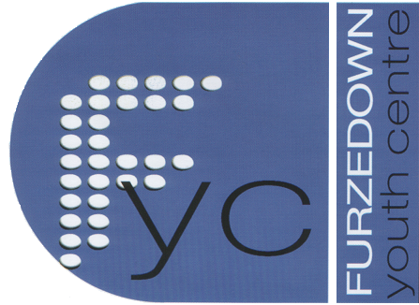
FURZEDOWN YOUTH CENTRE
Complaints form

To Whom It May Concern:

Name of person making the complaint____________________________________

Name of Staff Member receiving the complaint_____________________________

Date complaint was made_____________________

Date of acknowledgement of the complaint__________________________

