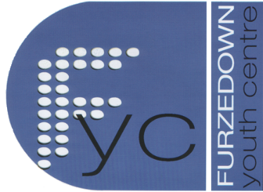

Furzedown Youth Centre Ltd

236 Mitcham Lane, London. SW16 6NT
tel: 020 8677 3947
charity no: 1111797
www.furzedownyouthcentre.org.uk

Flipout Wandsworth Trip

Dear Parents/Guardian,

Recently Madeleine was awarded this terms’ Jack Petchey prize. With the money she would like to do a trip to Flipout in Wandsworth. This trip will take place on Tuesday the 4th April and is open to all young people that attend FYC Juniors. We plan to meet outside the leisure centre at 9.30am and be back at FYC by 12pm.

The trip will be £4 per young person and they can bring extra money along for some drinks or snacks. Spaces for this trip are limited to 22, and these spaces will be allocated on a first come basis. If you want to come please make sure you bring the slip below back on Tuesday 21st March. (extra slips can be downloaded from our website) Please also fill in and return the attached consent form.

If you have any further questions or queries, please do not hesitate to get in touch on 07972 375 202 or by email; my address is furzedownyc@gmail.com.

Also for your information the last Juniors session this term will be the 21st March and we will be back on the 25th of April.

Blessing,

Bethany Goddard
Youth Work Manager
Furzedown Youth Centre

__________________________________________________________________________________________

I give permission for…………………………………............from FYC Juniors to attend the Flipout Wansdworth trip on Tuesday 4th of April 2017.

Emergency Contact: Name……………………………………………………………
Number ………………………………………………………..

Signed………………………………………………………… Date:……………………………..

